Alternate Procedure - Confined Space Entry Form
§1926.1203(e)(1) – (e)(2)

Application: This form applies to permit required confined spaces where all physical hazards in the space are eliminated or isolated through engineering controls so that the only hazard posed by the permit space is an actual or potential hazardous atmosphere; Examples of locations where confined spaces may occur include, but are not limited to, the following: Bins, boilers, pits, manholes, tanks, incinerators, scrubbers, concrete pier columns, sewers, transformer vaults, heating, ventilation, and air-conditioning ducts; storm drains, water mains, precast concrete and other pre-formed manhole units, drilled shafts, enclosed beams, vessels, digesters, lift stations, cesspools, silos, air receivers, sludge gates, air pre-heaters, step up transformers, turbines, chillers, bag houses, and/or mixers/reactors. This form establishes that there are no existing hazards associated with this confined space and that the planned work will not introduce a hazard. If entry conditions do not meet requirements or if conditions change, a PERMIT is required.
Instructions: This Alternate Procedure Confined Space Entry (APCSE) form must be completed before anyone enters the space and kept at or near the entrance to the space during entry. This form must be sent to the confined space program manager once the work is completed. To ensure entry conditions are acceptable, this form is good for one day only.

Confined Space

Reason for entry: | Entry date:
Location:
Space description:
Evaluate if new hazards will be created by the planned work (APCSE entry requires that the answer to all three questions be “No”)
Will any activities that could create a hazard be conducted inside the confined space, such as welding or breaking a line? No Yes If yes, describe:
Will hazardous chemicals be brought into the space that continuous forced air ventilation alone cannot make safe? No Yes If yes, specify:
Are there any conditions in or around this space that could adversely affect anyone who enters it? No Yes If yes, describe:

Air Monitoring Results (to be completed as needed before and during work)

Attendant will sample air Continuously Every minutes No sampling required because:
4Gas Monitor Make and Model |  |  | Unit or serial number | Calibration due date | Pre-use check performed by | Notes
2 |  |  | 4 |  | 2
Time | Sampled by | O  (20.9%) | C H  (LEL/LFL<10%) | CO  (<25 ppm) | H S  (<10 ppm) | Stratification | Other:
Continuous Forced Air Ventilation

Continuous forced air Ventilation

Evaluate if continuous forced air ventilation is adequate for safe entry (APCSE entry requires that the answer to all four questions be “Yes”)
Any actual or potential hazardous atmosphere can be made safe for entry using continuous forced air ventilation? No Yes
If no, describe:
Forced air ventilation must be so directed as to ventilate the immediate area where an entrant is or will be in the space? No Yes If no, describe:
Forced air ventilation exchange rate is 20 times per hour and must continue until all entrants have left the space? No Yes
If no, describe:
If yes, specify:
The forced air ventilation air supply is from a clean source and does not increase the hazard in the space? No Yes
If no, describe:
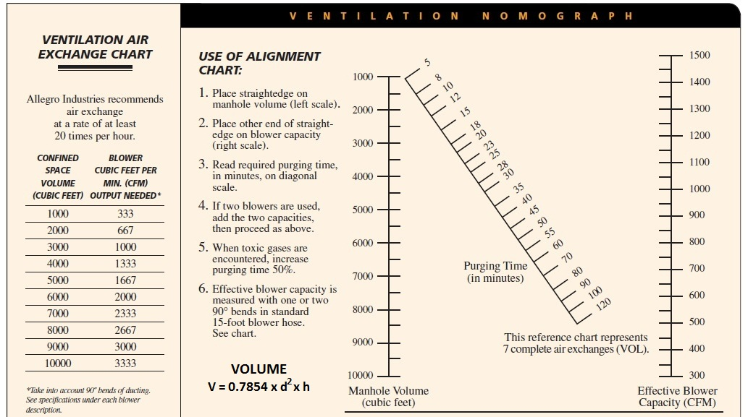
Personnel Entry and Exit Record (to be completed as needed before and during work)

 | Attendant name: | Entrant name: | Entrant name: | Entrant name: | Entrant name: | Entrant name:
Time in
Time out
Time in
Time out
Time in
Time out
Time in
Time out
Time in

Confirmation (must be signed by the confined space competent person before work begins)

I confirm that there are no existing hazards associated with this confined space and that the planned work will not introduce any. Competent Person Name:
Signature: | Date:

